IN MEMORIAM
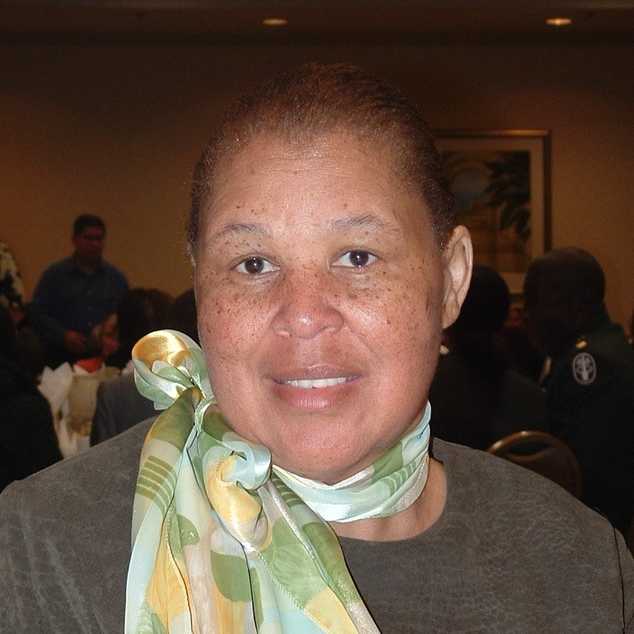
Fredonnia Price, RNC, MS, Charter President
Alpha Phi Chapter, Chi Eta Phi Sorority, Inc.

Alpha Phi Chapter, Chi Eta Phi Sorority, Inc., Willie Smith, President, mourn the passing of Fredonnia Price. Fredonnia passed peacefully on July 12, 2012 after a valiant fight with cancer.

Fredonnia’s nursing career started with becoming a Certified Nurse’s Assistant, onward to Licensed Vocational Nurse and finally Registered Nurse in 1978.

In 1991, Fredonnia began attending public events of the sorority’s Mu Chi Chapter in Los Angeles. The more Fredonnia found out about the sorority the more excited she became and therefore explored sorority membership. She drove 360 miles to Los Angeles to attend monthly meetings & classes. Her service project was to recruit RN’s from the Stockton area to form a new chapter. She took on this project with enthusiasm, talking constantly to all of the registered nurses she knew. Most were unaware of the organization but, undaunted, Fredonnia overcame all obstacles to accomplish her mission. On May 30, 1992, Alpha Phi Chapter was chartered and has been a dynamic and active chapter in the community ever since.

Fredonnia was our charter (first) president and totally devoted to the sorority and its purposes. One of the purposes of the sorority is to “elevate the plane of nursing.” She was committed to the recognition of nurses for their service and always looked for opportunities to honor individual nurses. She was responsible for several of the chapter members being recognized by the sorority’s Southwest Region. Fredonnia was actively successful in locating suitable candidates for our nursing scholarships.

She was instrumental in the formation of a Chi Eta Phi graduate chapter and undergraduate chapter in Oakland, Ca – Omicron Phi and Omicron Phi Beta.
Fredonnia encouraged the Basileus of Omicon Phi, Dawn Dailey to present her work with the national SIDS Campaign to the boule board and membership, leading to the organization, under the leadership of National President Dana Lopez, to adopt the Campaign as a national Chi Eta Phi campaign. She was also instrumental in the National organization’s funding of the Judi Davis Bone Marrow campaign.

Even in the last stages of her illness, she was thinking of the sorority. During her last hospitalization, she could hardly catch her breath but was speaking of projects she was working on to make our upcoming 2013 Regional Conference in Stockton, successful.

In addition to her service in Chi Eta Phi Sorority, Inc., Fredonnia was also active in other community organizations such as National Council of Negro Women, The Black Nurses Association and Packed With Pride. She was also active in her church, The Christian Life Center, Stockton, CA.
Alpha Phi Chapter will miss our fallen sister but, will be ever grateful for her successful effort to bring us to Chi Eta Phi Sorority, Inc. We wish sweet memories and blessings to her son, Jody Hardge, family, fellow sorority members and friends.

